Ex. No. 1 IMPLEMENTING BREADTH-FIRST SEARCH (BFS) AND DEPTH-FIRST SEARCH (DFS)

Date:

AIM:
The aim of implementing Breadth-First Search (BFS) and Depth-First Search (DFS) Algorithms are to traverse a graph or a tree data structure in a systematic way, visiting all nodes and edges in the structure in a particular order, without revisiting any node twice.

ALGORITHM:

Breadth-First Search (BFS) algorithm:

- Create an empty queue and enqueue the starting node
- Mark the starting node as visited
- While the queue is not empty, dequeue a node from the queue and visit it
- Enqueue all of its neighbors that have not been visited yet, and mark them as visited
- Repeat steps 3-4 until the queue is empty

Depth-First Search (DFS) algorithm:

- Mark the starting node as visited and print it
- For each adjacent node of the current node that has not been visited, repeat step 1
- If all adjacent nodes have been visited, backtrack to the previous node and repeat step 2
- Repeat steps 2-3 until all nodes have been visited

Program: BREADTH-FIRST SEARCH:
graph = {
'5' : ['3','7'],
'3' : ['2', '4'],
'7' : ['8'],
'2' : [],
'4' : ['8'],
'8' : []
}
visited = []
queue = []
def bfs(visited, graph, node): #function for BFS
visited.append(node)
queue.append(node)
while queue:
m = queue.pop(0)
print (m, end = " ")
for neighbour in graph[m]:
if neighbour not in visited:
visited.append(neighbour)
queue.append(neighbour)
print("Following is the Breadth-First Search")
bfs(visited, graph, '5') # function calling

OUTPUT:
BFS
Following is the Breadth-First Search 5 3 7 2 4 8

Program: DEPTH-FIRST SEARCH
graph = {
'5' : ['3','7'],
'3' : ['2', '4'],
'7' : ['8'],
'2' : [],
'4' : ['8'],
'8' : []
}
visited = set()
def dfs(visited, graph, node): #function for dfs
if node not in visited:
print (node)
visited.add(node)
for neighbour in graph[node]:
dfs(visited, graph, neighbour)
print("Following is the Depth-First Search")
dfs(visited, graph, '5')
OUTPUT:
DFS
Following is the Depth-First Search 5
3
2
4
8
7

RESULT:
Thus the python program for implementing BFS and DFS algorithm is executed successfully and the output is verified.

Ex. No. 2 IMPLEMENTING INFORMED SEARCH ALGORITHMS LIKE A* AND MEMORY-BOUNDED A*
Date:

AIM:
The aim of a C program for implementing informed search algorithms like A* and memory-bounded A* is to efficiently find the shortest path between two points in a graph or network. The A* algorithm is a heuristic-based search algorithm that finds the shortest path between two points by evaluating the cost function of each possible path. The memory- bounded A* algorithm is a variant of the A* algorithm that uses a limited amount of memory and is suitable for large search spaces.

ALGORITHM:

Algorithm for A*
  - Initialize the starting node with a cost of zero and add it to an open list.
  - While the open list is not empty:
- Find the node with the lowest cost in the open list and remove it.
- If this node is the goal node, return the path to this node.
- Generate all successor nodes of the current node.
- For each successor node, calculate its cost and add it to the open list.
  - If the open list is empty and the goal node has not been found, then there is no path from the start node to the goal node.

Algorithm for memory-bounded A*
- Initialize the starting node with a cost of zero and add it to an open list and a closed list.
- While the open list is not empty:
- Find the node with the lowest cost in the open list and remove it.
- If this node is the goal node, return the path to this node.
- Generate all successor nodes of the current node.
- For each successor node, calculate its cost and add it to the open list if it is not in the closed list. e. If the open list is too large, remove the node with the highest cost from the open list and add it to the closed list.
f. Add the current node to the closed list.
- If the open list is empty and the goal node has not been found, then there is no path from the start node to the goal node.

Program: A* ALGORITHM
from queue importPriorityQueue v =14
graph =[[] fori inrange(v)]
# Function For Implementing Best First Search # Gives output path having lowest cost
defbest_first_search(actual_Src, target, n): visited =[False] *n
pq =PriorityQueue() pq.put((0, actual_Src)) visited[actual_Src] =True
whilepq.empty() ==False:
u =pq.get()[1]
# Displaying the path having lowest cost print(u, end=" ")
ifu ==target: break
forv, c ingraph[u]: ifvisited[v] ==False:
visited[v] =True pq.put((c, v))
print()
# Function for adding edges to graph
defaddedge(x, y, cost): graph[x].append((y, cost))
graph[y].append((x, cost))
# The nodes shown in above example(by alphabets) are # implemented using integers addedge(x,y,cost); addedge(0, 1, 3)
addedge(0, 2, 6)
addedge(0, 3, 5)
addedge(1, 4, 9)
addedge(1, 5, 8)
addedge(2, 6, 12)
addedge(2, 7, 14)
addedge(3, 8, 7)
addedge(8, 9, 5)
addedge(8, 10, 6)
addedge(9, 11, 1)
addedge(9, 12, 10)
addedge(9, 13, 2)

source =0
target =9 best_first_search(source, target, v)

Output:
A*
0 1 3 2 8 9

Program: MEMORY BOUNDED A *

Import heapq
import math

classPriorityQueue:
"""Priority queue implementation using heapq""" def init (self):
self.elements = []

defis_empty(self):
returnlen(self.elements) == 0

def put(self, item, priority): heapq.heappush(self.elements, (priority, item))

def get(self): returnheapq.heappop(self.elements)[1]

class Node:
"""Node class for representing the search tree"""
def init (self, state, parent=None, action=None, path_cost=0): self.state = state
self.parent = parent self.action = action self.path_cost = path_cost

def lt (self, other):
returnself.path_cost + heuristic(self.state) <other.path_cost + heuristic(other.state)

def eq (self, other):
returnself.state == other.state

def heuristic(state):
"""Heuristic function for estimating the cost to reach the goal state""" # Example heuristic function - Euclidean distance to the goal
goal_state = (0, 0) # Replace with actual goal state returnmath.sqrt((state[0] - goal_state[0])**2 + (state[1] - goal_state[1])**2)

defmemory_bounded_a_star_search(start_state, max_memory): """Memory-bounded A* search algorithm"""
frontier = PriorityQueue() frontier.put(Node(start_state), 0) explored = set()
memory = {start_state: 0}

while not frontier.is_empty(): node = frontier.get()

ifnode.state not in explored: explored.add(node.state)

ifis_goal_state(node.state): returnget_solution_path(node)

forchild_state, action, step_cost in get_successor_states(node.state): child_node = Node(child_state, node, action, node.path_cost + step_cost) child_node_f = child_node.path_cost + heuristic(child_state) ifchild_state not in memory or child_node_f< memory[child_state]: frontier.put(child_node, child_node_f)
memory[child_state] = child_node_f

whilememory_usage(memory) >max_memory: state_to_remove = min(memory, key=memory.get) del memory[state_to_remove]
return None defget_successor_states(state):
"""Function for generating successor states"""
# Replace with actual successor state generation logic return []

defis_goal_state(state):
"""Function for checking if a state is the goal state""" # Replace with actual goal state checking logic
return False

defget_solution_path(node):
"""Function for retrieving the solution path""" path = []
whilenode.parent is not None: path.append((node.action, node.state)) node = node.parent
path.reverse() return path

defmemory_usage(memory):
"""Function for estimating the memory usage of a dictionary""" return sum(memory.values())

OUTPUT:
Memory Bounded A* 48
48
98*
SyntaxError: incomplete input 9*
SyntaxError: incomplete input 8
8
87/
SyntaxError: incomplete input 7
7
8
8

RESULT:
Thus the python program for implementing informed search algorithms like A* and memory-bounded A* has executed successfully and output is verified.

Ex. No.3 IMPLEMENT NAIVE BAYES MODEL
Date:

AIM:
The aim of the Naïve Bayes algorithm is to classify a given set of data points into different classes based on the probability of each data point belonging to a particular class. This algorithm is based on the Bayes theorem, which states that the probability of an event occurring given the prior knowledge of another event can be calculated using conditional probability.

ALGORITHM:

- Collect the dataset: The first step in using Naïve Bayes is to collect a dataset that contains a set of data points and their corresponding classes.
- Prepare the data: The next step is to preprocess the data and prepare it for the Naïve Bayes algorithm. This involves removing any unnecessary features or attributes and normalizing the data.
- Compute the prior probabilities: The prior probabilities of each class can be computed by calculating the number of data points belonging to each class and dividing it by the total number of data points.
- Compute the likelihoods: The likelihoods of each feature for each class can be computed by calculating the conditional probability of the feature given the class. This involves counting the number of data points in each class that have the feature and dividing it by the total number of data points in that class.
- Compute the posterior probabilities: The posterior probabilities of each class can be computed by multiplying the prior probability of the class with the product of the likelihoods of each feature for that class.
- Make predictions: Once the posterior probabilities have been computed for each class, the Naïve Bayes algorithm can be used to make predictions by selecting the class with the highest probability.
- Evaluate the model: The final step is to evaluate the performance of the Naïve Bayes model. This can be done by computing various performance metrics such as accuracy, precision, recall, and F1 score.

Program:
#Importing the libraries
import numpy as nm
import matplotlib.pyplot as mtp
import pandas as pd

# Importing the dataset
dataset = pd.read_csv('User_Data.csv')
x = dataset.iloc[:, [2, 3]].values
y = dataset.iloc[:, 4].values

# Splitting the dataset into the Training set and Test set
from sklearn.model_selection import train_test_split
x_train, x_test, y_train, y_test = train_test_split(x, y, test_size = 0.25, random_state = 0)

# Feature Scaling
from sklearn.preprocessing import StandardScaler
sc = StandardScaler()
x_train = sc.fit_transform(x_train)
x_test = sc.transform(x_test)

# Fitting Naive Bayes to the Training set
from sklearn.naive_bayes import GaussianNB
classifier = GaussianNB()
classifier.fit(x_train, y_train)

# Predicting the Test set results
y_pred = classifier.predict(x_test)

# Visualising the Training set results
from matplotlib.colors import ListedColormap
x_set, y_set = x_train, y_train
X1, X2 = nm.meshgrid(nm.arange(start = x_set[:, 0].min() - 1, stop = x_set[:, 0].max() + 1, step = 0.01),
nm.arange(start = x_set[:, 1].min() - 1, stop = x_set[:, 1].max() + 1, step = 0.01))
mtp.contourf(X1, X2, classifier.predict(nm.array([X1.ravel(), X2.ravel()]).T).reshape(X1.shape),
alpha = 0.75, cmap = ListedColormap(('purple', 'green')))
mtp.xlim(X1.min(), X1.max())
mtp.ylim(X2.min(), X2.max())
for i, j in enumerate(nm.unique(y_set)):
mtp.scatter(x_set[y_set == j, 0], x_set[y_set == j, 1],
c = ListedColormap(('purple', 'green'))(i), label = j)
mtp.title('Naive Bayes (Training set)')
mtp.xlabel('Age')
mtp.ylabel('Estimated Salary')
mtp.legend()
mtp.show()

# test model
predictions = getPredictions(info, test_data) accuracy = accuracy_rate(test_data, predictions) print("Accuracy of your model is: ", accuracy)

# Visualising the Test set results
from matplotlib.colors import ListedColormap
x_set, y_set = x_test, y_test
X1, X2 = nm.meshgrid(nm.arange(start = x_set[:, 0].min() - 1, stop = x_set[:, 0].max() + 1, step = 0.01),
nm.arange(start = x_set[:, 1].min() - 1, stop = x_set[:, 1].max() + 1, step = 0.01))
mtp.contourf(X1, X2, classifier.predict(nm.array([X1.ravel(), X2.ravel()]).T).reshape(X1.shape),
alpha = 0.75, cmap = ListedColormap(('purple', 'green')))
mtp.xlim(X1.min(), X1.max())
mtp.ylim(X2.min(), X2.max())
for i, j in enumerate(nm.unique(y_set)):
mtp.scatter(x_set[y_set == j, 0], x_set[y_set == j, 1],
c = ListedColormap(('purple', 'green'))(i), label = j)
mtp.title('Naive Bayes (test set)')
mtp.xlabel('Age')
mtp.ylabel('Estimated Salary')
mtp.legend()
mtp.show()

OUTPUT:
Visualising the Training set results
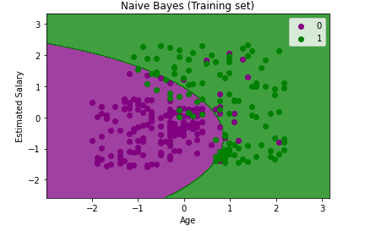

Visualising the Test set results
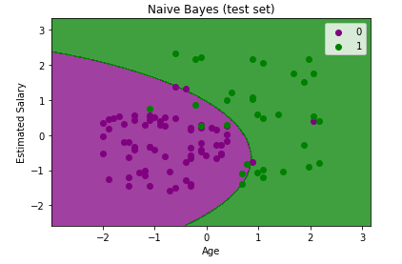

Total numbers of examples are: 200
Out of these, training examples are: 140 Test examples are: 60
Accuracy of your model is: 71.2376788

RESULT:
Thus the python program for Naive Bayes is executed successfully and output is verified.

Ex.No.4 IMPLEMENT BAYESIAN NETWORKS
Date:

AIM:
The aim of implementing Bayesian Networks is to model the probabilistic
relationships between a set of variables. A Bayesian Network is a graphical model that represents the conditional dependencies between different variables in a probabilistic manner. It is a powerful tool for reasoning under uncertainty and can be used for a wide range of applications, including decision making, risk analysis, and prediction.
.

ALGORITHM:

- Define the variables: The first step in implementing a Bayesian Network is to define the variables that will be used in the model. Each variable should be clearly defined and its possible states should be enumerated.
- Determine the relationships between variables: The next step is to determine the probabilistic relationships between the variables. This can be done by identifying the causal relationships between the variables or by using data to estimate the conditional probabilities of each variable given its parents.
- Construct the Bayesian Network: The Bayesian Network can be constructed by representing the variables as nodes in a directed acyclic graph (DAG). The edges between the nodes represent the conditional dependencies between the variables.
- Assign probabilities to the variables: Once the structure of the Bayesian Network has been defined, the probabilities of each variable must be assigned. This can be done by using expert knowledge, data, or a combination of both.
- Inference: Inference refers to the process of using the Bayesian Network to make predictions or draw conclusions. This can be done by using various inference algorithms, such as variable elimination or belief propagation.
- Learning: Learning refers to the process of updating the probabilities in the Bayesian Network based on new data. This can be done using various learning algorithms, such as maximum likelihood or Bayesian learning.
- Evaluation: The final step in implementing a Bayesian Network is to evaluate its performance. This can be done by comparing the predictions of the model to actual data and computing various performance metrics, such as accuracy or precision.

Program:
import pandas as pd # for data manipulation
import networkx as nx # for drawing graphs
import matplotlib.pyplot as plt # for drawing graphs

# for creating Bayesian Belief Networks (BBN)
from pybbn.graph.dag import Bbn
from pybbn.graph.edge import Edge, EdgeType
from pybbn.graph.jointree import EvidenceBuilder
from pybbn.graph.node import BbnNode
from pybbn.graph.variable import Variable
from pybbn.pptc.inferencecontroller import InferenceController

# Set Pandas options to display more columns
pd.options.display.max_columns=50

# Read in the weather data csv
df=pd.read_csv('weatherAUS.csv', encoding='utf-8')

# Drop records where target RainTomorrow=NaN
df=df[pd.isnull(df['RainTomorrow'])==False]

# For other columns with missing values, fill them in with column mean
df=df.fillna(df.mean())

# Create bands for variables that we want to use in the model
df['WindGustSpeedCat']=df['WindGustSpeed'].apply(lambda x: '0.<=40' if x<=40 else
'1.40-50' if 40<x<=50 else '2.>50')
df['Humidity9amCat']=df['Humidity9am'].apply(lambda x: '1.>60' if x>60 else '0.<=60')
df['Humidity3pmCat']=df['Humidity3pm'].apply(lambda x: '1.>60' if x>60 else '0.<=60')

# Show a snaphsot of data
df

# Create nodes by manually typing in probabilities
H9am = BbnNode(Variable(0, 'H9am', ['<=60', '>60']), [0.30658, 0.69342])
H3pm = BbnNode(Variable(1, 'H3pm', ['<=60', '>60']), [0.92827, 0.07173,
0.55760, 0.44240])
W = BbnNode(Variable(2, 'W', ['<=40', '40-50', '>50']), [0.58660, 0.24040, 0.17300])
RT = BbnNode(Variable(3, 'RT', ['No', 'Yes']), [0.92314, 0.07686,
0.89072, 0.10928,
0.76008, 0.23992,
0.64250, 0.35750,
0.49168, 0.50832,
0.32182, 0.67818])
# This function helps to calculate probability distribution, which goes into BBN (note, can handle up to 2 parents)
def probs(data, child, parent1=None, parent2=None):
if parent1==None:
# Calculate probabilities
prob=pd.crosstab(data[child], 'Empty', margins=False, normalize='columns').sort_index().to_numpy().reshape(-1).tolist()
elif parent1!=None:
# Check if child node has 1 parent or 2 parents
if parent2==None:
# Caclucate probabilities
prob=pd.crosstab(data[parent1],data[child], margins=False, normalize='index').sort_index().to_numpy().reshape(-1).tolist()
else:
# Caclucate probabilities
prob=pd.crosstab([data[parent1],data[parent2]],data[child], margins=False, normalize='index').sort_index().to_numpy().reshape(-1).tolist()
else: print("Error in Probability Frequency Calculations")
return prob

# Create nodes by using our earlier function to automatically calculate probabilities
H9am = BbnNode(Variable(0, 'H9am', ['<=60', '>60']), probs(df, child='Humidity9amCat'))
H3pm = BbnNode(Variable(1, 'H3pm', ['<=60', '>60']), probs(df, child='Humidity3pmCat', parent1='Humidity9amCat'))
W = BbnNode(Variable(2, 'W', ['<=40', '40-50', '>50']), probs(df, child='WindGustSpeedCat'))
RT = BbnNode(Variable(3, 'RT', ['No', 'Yes']), probs(df, child='RainTomorrow', parent1='Humidity3pmCat', parent2='WindGustSpeedCat'))

# Create Network
bbn = Bbn() \
.add_node(H9am) \
.add_node(H3pm) \
.add_node(W) \
.add_node(RT) \
.add_edge(Edge(H9am, H3pm, EdgeType.DIRECTED)) \
.add_edge(Edge(H3pm, RT, EdgeType.DIRECTED)) \
.add_edge(Edge(W, RT, EdgeType.DIRECTED))

# Convert the BBN to a join tree
join_tree = InferenceController.apply(bbn)

# Set node positions
pos = {0: (-1, 2), 1: (-1, 0.5), 2: (1, 0.5), 3: (0, -1)}

# Set options for graph looks
options = {
"font_size": 16,
"node_size": 4000,
"node_color": "white",
"edgecolors": "black",
"edge_color": "red",
"linewidths": 5,
"width": 5,}

# Generate graph
n, d = bbn.to_nx_graph()
nx.draw(n, with_labels=True, labels=d, pos=pos, **options)

# Update margins and print the graph
ax = plt.gca()
ax.margins(0.10)
plt.axis("off")
plt.show()

# Define a function for printing marginal probabilities
def print_probs():
for node in join_tree.get_bbn_nodes():
potential = join_tree.get_bbn_potential(node)
print("Node:", node)
print("Values:")
print(potential)
print('----------------')

# Use the above function to print marginal probabilities
print_probs()

OUTPUT: Generated Graph

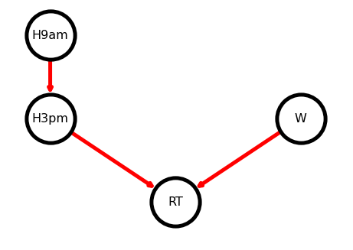

Printing Marginal Probabilities:

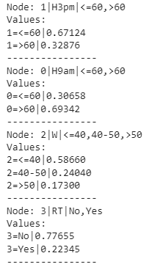

RESULT:
Thus the python program for implementing Bayesian Network has executed successfully and output is verified.

Ex.No.5 BUILD REGRESSION MODEL
Date:
AIM:
To The aim of building a regression model is to predict a continuous numerical outcome variable based on one or more input variables. There are several algorithms that can be used to build regression models, including linear regression, polynomial regression, decision trees, random forests, and neural networks.

ALGORITHM:

- Collecting and cleaning the data: The first step in building a regression model is to gather the data needed for analysis and ensure that it is clean and consistent. This may involve removing missing values, outliers, and other errors.
- Exploring the data: Once the data is cleaned, it is important to explore it to gain an understanding of the relationships between the input and outcome variables. This may involve calculating summary statistics, creating visualizations, and testing for correlations.
- Choosing the algorithm: Based on the nature of the problem and the characteristics of the data, an appropriate regression algorithm is chosen.
- Preprocessing the data: Before applying the regression algorithm, it may be necessary to preprocess the data to ensure that it is in a suitable format. This may involve standardizing or normalizing the data, encoding categorical variables, or applying feature engineering techniques.
- Training the model: The regression model is trained on a subset of the data, using an optimization algorithm to find the values of the model parameters that minimize the difference between the predicted and actual values.
- Evaluating the model: Once the model is trained, it is evaluated using a separate test dataset to determine its accuracy and generalization performance. Metrics such as mean squared error, R-squared, or root mean squared error can be used to assess the model's performance.
- Improving the model: Based on the evaluation results, the model can be refined by adjusting the model parameters or using different algorithms.
- Deploying the model: Finally, the model can be deployed to make predictions on new data.

PROGRAM:
SIMPLE LINEAR REGRESSION:
import numpy as np
from sklearn.linear_model import LinearRegression
x = np.array([5, 15, 25, 35, 45, 55]).reshape((-1, 1))
y = np.array([5, 20, 14, 32, 22, 38])
model = LinearRegression()
model.fit(x, y)
model = LinearRegression().fit(x, y)
r_sq = model.score(x, y)
print(f"coefficient of determination: {r_sq}")
print(f"intercept: {model.intercept_}")
print(f"slope: {model.coef_}")
new_model = LinearRegression().fit(x, y.reshape((-1, 1)))
print(f"intercept: {new_model.intercept_}")
print(f"slope: {new_model.coef_}")
y_pred = model.predict(x)
print(f"predicted response:\n{y_pred}")
y_pred = model.intercept_ + model.coef_ * x
print(f"predicted response:\n{y_pred}")
x_new = np.arange(5).reshape((-1, 1))
y_new = model.predict(x_new)
y_new

OUTPUT:
coefficient of determination: 0.7158756137479542
intercept: 5.633333333333329
slope: [0.54]
intercept: [5.63333333]
slope: [[0.54]]
predicted response:
[ 8.33333333 13.73333333 19.13333333 24.53333333 29.93333333 35.33333333]
predicted response:
[[ 8.33333333]
[13.73333333]
[19.13333333]
[24.53333333]
[29.93333333]
[35.33333333]]
array([5.63333333, 6.17333333, 6.71333333, 7.25333333, 7.79333333])

MULTIPLE LINEAR REGRESSION:
import numpy as np
from sklearn.linear_model import LinearRegression
x = [[0, 1], [5, 1], [15, 2], [25, 5], [35, 11], [45, 15], [55, 34], [60, 35]]
y = [4, 5, 20, 14, 32, 22, 38, 43]
x, y = np.array(x), np.array(y)
model = LinearRegression().fit(x, y)
r_sq = model.score(x, y)
print(f"coefficient of determination: {r_sq}")
print(f"intercept: {model.intercept_}")
print(f"coefficients: {model.coef_}")
y_pred = model.predict(x)
print(f"predicted response:\n{y_pred}")
y_pred = model.intercept_ + np.sum(model.coef_ * x, axis=1)
print(f"predicted response:\n{y_pred}")
x_new = np.arange(10).reshape((-1, 2))
x_new
y_new = model.predict(x_new)
y_new

OUTPUT:
coefficient of determination: 0.8615939258756776
intercept: 5.52257927519819
coefficients: [0.44706965 0.25502548]
predicted response:
[ 5.77760476 8.012953 12.73867497 17.9744479 23.97529728 29.4660957
38.78227633 41.27265006]
predicted response:
[ 5.77760476 8.012953 12.73867497 17.9744479 23.97529728 29.4660957
38.78227633 41.27265006]
array([ 5.77760476, 7.18179502, 8.58598528, 9.99017554, 11.3943658 ])

RESULT:
Thus the python program for build regression models is executed successfully and output is verified.

Ex.No.6 BUILD DECISION TREES AND RANDOM FORESTS
Date:

AIM:
. The aim of building decision trees and random forests is to create models that can be used to predict a target variable based on a set of input features. Decision trees and random forests are both popular machine learning algorithms for building predictive models.

ALGORITHM:

Decision Trees:

- Select the feature that best splits the data: The first step is to select the feature that best separates the data into groups with different target values.
- Recursively split the data: For each group created in step 1, repeat the process of selecting the best feature to split the data until a stopping criterion is met. The stopping criterion may be a maximum tree depth, a minimum number of samples in a leaf node, or another condition.
- Assign a prediction value to each leaf node: Once the tree is built, assign a prediction value to each leaf node. This value may be the mean or median target value of the samples in the leaf node.

Random Forest:

- Randomly select a subset of features: Before building each decision tree, randomly select a subset of features to consider for splitting the data.
- Build multiple decision trees: Build multiple decision trees using the process described above, each with a different subset of features.
- Aggregate the predictions: When making predictions on new data, aggregate the predictions from all decision trees to obtain a final prediction value. This can be done by taking the average or majority vote of the predictions

PROGRAM:
import pandas as pd
import numpy as np
#Visalization libraries
import matplotlib.pyplot as plt
import seaborn as sns
%matplotlib inline
raw_data = pd.read_csv('kyphosis.csv')
raw_data.info()
sns.pairplot(raw_data, hue = 'Kyphosis')
from sklearn.model_selection import train_test_split
x = raw_data.drop('Kyphosis', axis = 1)
y = raw_data['Kyphosis']
x_training_data, x_test_data, y_training_data, y_test_data = train_test_split(x, y, test_size = 0.3)
from sklearn.tree import DecisionTreeClassifier
model = DecisionTreeClassifier()
model.fit(x_training_data, y_training_data)
predictions = model.predict(x_test_data)
from sklearn.metrics import classification_report
from sklearn.metrics import confusion_matrix
print(classification_report(y_test_data, predictions))
print(confusion_matrix(y_test_data, predictions))

OUTPUT: Pairplot

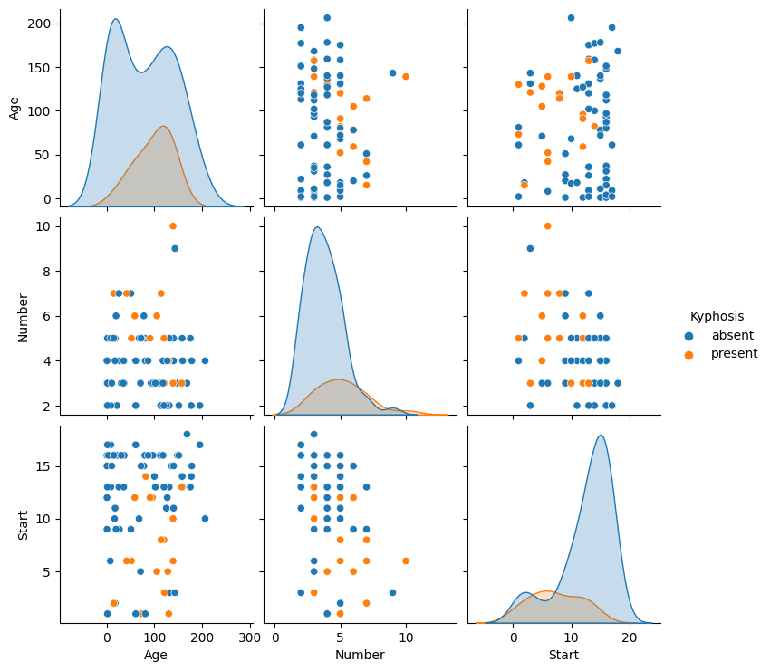
Model fit:
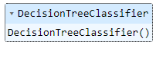
Classification report
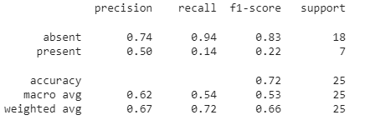
Confusion matrix

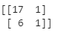

RESULT:
Thus the python program for decision trees and random forest has been executed successfully and output is verified.

Ex.No.7 BUILD SVM MODELS
Date:

AIM:
The aim of this Python code is to demonstrate how to use the scikit-learn library to
train support vector machine (SVM) models for classification tasks.

ALGORITHM:
- Load a dataset using the pandas library
- Split the dataset into training and testing sets using training_test_split function from scikit-learn.
- Train three SVM models with different kernels (linear, polynomial, and RBF) using SVC function from scikit-learn.
- Predict the test set labels using the trained models.
- Evaluate the accuracy of the models using accuracy_score function from scikit_learn.
- Print the accuracy of each model.

PROGRAM:
import numpy as np
import matplotlib.pyplot as plt
import pandas as pd
dataset = pd.read_csv('Social_Network_Ads.csv')
X = dataset.iloc[:, [2, 3]].values
y = dataset.iloc[:, 4].values
from sklearn.model_selection import train_test_split
X_train, X_test, y_train, y_test = train_test_split(X, y, test_size = 0.25, random_state = 0)
from sklearn.preprocessing import StandardScaler
sc = StandardScaler()
X_train = sc.fit_transform(X_train)
X_test = sc.transform(X_test)
from sklearn.svm import SVC
classifier = SVC(kernel = 'rbf', random_state = 0)
classifier.fit(X_train, y_train)
y_pred = classifier.predict(X_test)
from sklearn.metrics import confusion_matrix, accuracy_score
cm = confusion_matrix(y_test, y_pred)
print(cm)
accuracy_score(y_test,y_pred)

from matplotlib.colors import ListedColormap
X_set, y_set = X_test, y_test
X1, X2 = np.meshgrid(np.arange(start = X_set[:, 0].min() - 1, stop = X_set[:, 0].max() + 1, step = 0.01),
np.arange(start = X_set[:, 1].min() - 1, stop = X_set[:, 1].max() + 1, step = 0.01))
plt.contourf(X1, X2, classifier.predict(np.array([X1.ravel(), X2.ravel()]).T).reshape(X1.shape),
alpha = 0.75, cmap = ListedColormap(('red', 'green')))
plt.xlim(X1.min(), X1.max())
plt.ylim(X2.min(), X2.max())
for i, j in enumerate(np.unique(y_set)):
plt.scatter(X_set[y_set == j, 0], X_set[y_set == j, 1],
c = ListedColormap(('red', 'green'))(i), label = j)
plt.title('SVM (Test set)')
plt.xlabel('Age')
plt.ylabel('Estimated Salary')
plt.legend()
plt.show()

OUTPUT:
Confusion matrix and Accuracy:
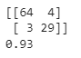

Matplot:
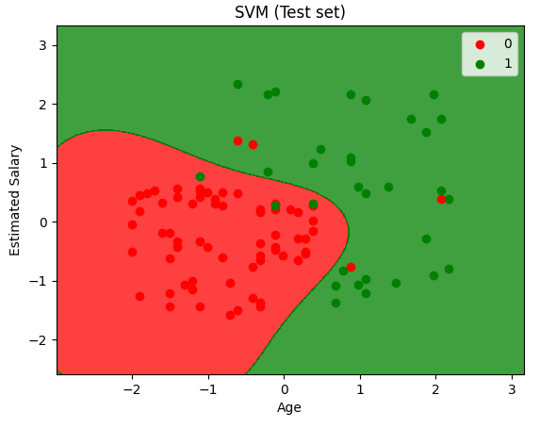

RESULT:
Thus the python program for Build SVM Model has been executed successfully and output is verified.

Ex.No.8 IMPLEMENT ENSEMBLING TECHNIQUES
Date:

AIM:
The aim of ensembling is to combine the predictions of multiple individual models, known as base models, in order to produce a final prediction that is more accurate and reliable than any individual model. (Voting,Bagging,Boosting)

ALGORITHM:

- Load the dataset and split it into training and testing sets.
- Choose the base models to be included in the ensemble.
- Train each base model on the training set.
- Combine the predictions of the base models using the chosen ensembling technique (voting, bagging, boosting, etc.).
- Evaluate the performance of the ensemble model on the testing set.
- If the performance is satisfactory, deploy the ensemble model for making predictions on new data.

PROGRAM:

# Example Of Evaluating a Bagging Ensemble For Classification
from numpy import mean
from numpy import std
from sklearn.datasets import make_classification
from sklearn.model_selection import cross_val_score
from sklearn.model_selection import RepeatedStratifiedKFold
from sklearn.ensemble import BaggingClassifier
# create the synthetic classification dataset
X, y = make_classification(random_state=1)
# configure the ensemble model
model = BaggingClassifier(n_estimators=50)
# configure the resampling method
cv = RepeatedStratifiedKFold(n_splits=10, n_repeats=3, random_state=1)
# evaluate the ensemble on the dataset using the resampling method
n_scores = cross_val_score(model, X, y, scoring='accuracy', cv=cv, n_jobs=-1)
# report ensemble performance
print('Mean Accuracy: %.3f (%.3f)' % (mean(n_scores), std(n_scores)))

# Example of Evaluating a Voting Ensemble For Classification
from numpy import mean
from numpy import std
from sklearn.datasets import make_classification
from sklearn.model_selection import cross_val_score
from sklearn.model_selection import RepeatedStratifiedKFold
from sklearn.ensemble import VotingClassifier
from sklearn.naive_bayes import GaussianNB
from sklearn.linear_model import LogisticRegression
# create the synthetic classification dataset
X, y = make_classification(random_state=1)
# configure the models to use in the ensemble
models = [('lr', LogisticRegression()), ('nb', GaussianNB())]
# configure the ensemble model
model = VotingClassifier(models, voting='soft')
# configure the resampling method
cv = RepeatedStratifiedKFold(n_splits=10, n_repeats=3, random_state=1)
# evaluate the ensemble on the dataset using the resampling method
n_scores = cross_val_score(model, X, y, scoring='accuracy', cv=cv, n_jobs=-1)
# report ensemble performance
print('Mean Accuracy: %.3f (%.3f)' % (mean(n_scores), std(n_scores)))

OUTPUT:

Bagging Ensemble

Mean Accuracy: 0.950 (0.072)

Voting Ensemble

Mean Accuracy: 0.960 (0.061)

RESULT:
Thus the python program for Implement ensemble techniques was executed and verified successfully.

Ex.No.9 IMPLEMENT CLUSTERING ALGORITHMS
Date:

AIM:
The aim of clustering is to find patterns and structure in data that may not be immediately apparent, and to discover relationships and associations between data points.

ALGORITHM:
- Data preparation: The first step is to prepare the data that we want to cluster. This may involve data cleaning, normalization, and feature extraction, depending on the type and quality of the data.
- Choosing a distance metric: The next step is to choose a distance metric or similarity measure that will be used to determine the similarity between data points. Common distance metrics include Euclidean distance, Manhattan distance, and cosine similarity.
- Choosing a clustering algorithm: There are many clustering algorithms available, each with its own strengths and weaknesses. Some popular clustering algorithms include K- Means, Hierarchical clustering, and DBSCAN.
- Choosing the number of clusters: Depending on the clustering algorithm chosen, we may need to specify the number of clusters we want to form. This can be done using domain knowledge or by using techniques such as the elbow method or silhouette analysis.
- Cluster assignment: Once the clusters have been formed, we need to assign each data point to its nearest cluster based on the chosen distance metric.
- Interpretation and evaluation: Finally, we need to interpret and evaluate the results of the clustering algorithm to determine if the clustering has produced meaningful and useful insights.

PROGRAM:
# k-means clustering
from numpy import unique
from numpy import where
from sklearn.datasets import make_classification
from sklearn.cluster import KMeans
from matplotlib import pyplot
# define dataset
X, _ = make_classification(n_samples=1000, n_features=2, n_informative=2, n_redundant=0, n_clusters_per_class=1, random_state=4)
# define the model
model = KMeans(n_clusters=2)
# fit the model
model.fit(X)
# assign a cluster to each example
yhat = model.predict(X)
# retrieve unique clusters
clusters = unique(yhat)
# create scatter plot for samples from each cluster
for cluster in clusters:
# get row indexes for samples with this cluster
row_ix = where(yhat == cluster)
# create scatter of these samples
pyplot.scatter(X[row_ix, 0], X[row_ix, 1])
# show the plot
pyplot.show()

OUTPUT:
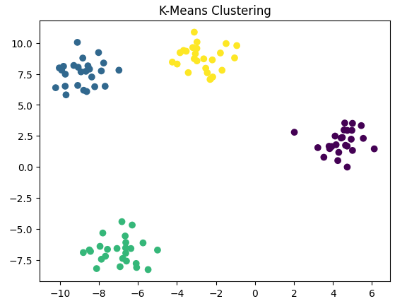
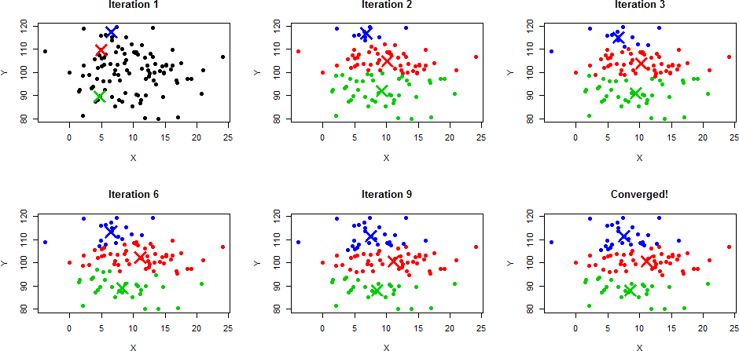

RESULT:
Thus the python program for implementing clustering algorithms has been executed successfully and the output is verified.

Ex.No. 10 Implement EM for Bayesian networks
Date:

AIM:
The aim of implementing EM for Bayesian networks is to learn the parameters of the network from incomplete or noisy data. This involves estimating the conditional probability distributions (CPDs) for each node in the network given the observed data. The EM algorithm is particularly useful when some of the variables are hidden or unobserved, as it can estimate the likelihood of the hidden variables based on the observed data.

ALGORITHM:
- Initialize the parameters: Start by initializing the parameters of the Bayesian network, such as the CPDs for each node. These can be initialized randomly or using some prior knowledge.
- E-step: In the E-step, we estimate the expected sufficient statistics for the unobserved variables in the network, given the observed data and the current parameter estimates. This involves computing the posterior probability distribution over the hidden variables, given the observed data and the current parameter estimates.
- M-step: In the M-step, we maximize the expected log-likelihood of the observed data with respect to the parameters. This involves updating the parameter estimates using the expected sufficient statistics computed in the E-step.
- Repeat steps 2 and 3 until convergence: Iterate between the E-step and M-step until the parameter estimates converge, or some other stopping criterion is met.

PROGRAM:

OUTPUT:
Print equilateral triangle Pyramid using asterisk symbol
Enter no.of rows:5
*
* *
* * *
* * * *
* * * * *

RESULT:
Thus the python program to print Pyramid pattern was executed and verified successfully.

Ex.No.11 BUILD SIMPLE NN MODELS
Date:

AIM:
The aim of building simple neural network (NN) models is to create a basic architecture that can learn patterns from data and make predictions based on the input. This can involve defining the structure of the NN, selecting appropriate activation functions, and tuning the hyperparameters to optimize the performance of the model.

ALGORITHM:
- Data preparation: Preprocess the data to make it suitable for training the NN. This may involve normalizing the input data, splitting the data into training and validation sets, and encoding the output variables if necessary.
- Define the architecture: Choose the number of layers and neurons in the NN, and define the activation functions for each layer. The input layer should have one neuron per input feature, and the output layer should have one neuron per output variable.
- Initialize the weights: Initialize the weights of the NN randomly, using a small value to avoid saturating the activation functions.
- Forward propagation: Feed the input data forward through the NN, applying the activation functions at each layer, and compute the output of the NN.
- Compute the loss: Calculate the error between the predicted output and the true output, using a suitable loss function such as mean squared error or cross-entropy.
- Backward propagation: Compute the gradient of the loss with respect to the weights, using the chain rule and backpropagate the error through the NN to adjust the weights.
- Update the weights: Adjust the weights using an optimization algorithm such as stochastic gradient descent or Adam, and repeat steps 4-7 for a fixed number of epochs or until the performance on the validation set stops improving.
- Evaluate the model: Test the performance of the model on a held-out test set and report the accuracy or other performance metrics.

PROGRAM:
import tensorflow as tf
from tensorflow import keras

# Load the MNIST dataset
(x_train, y_train), (x_test, y_test) = keras.datasets.mnist.load_data()

# Normalize the input data x_train = x_train / 255.0 x_test = x_test / 255.0

# Define the model architecture model = keras.Sequential([
keras.layers.Flatten(input_shape=(28, 28)), keras.layers.Dense(128, activation='relu'), keras.layers.Dense(10, activation='softmax')
])

# Compile the model model.compile(optimizer='adam',
loss='sparse_categorical_crossentropy', metrics=['accuracy'])

# Train the model
model.fit(x_train, y_train, epochs=10, validation_data=(x_test, y_test))

# Evaluate the model
test_loss, test_acc = model.evaluate(x_test, y_test, verbose=2) print('Test accuracy:', test_acc)

OUTPUT:
Epoch 1/10
1875/1875 [==============================] - 14s 7ms/step - loss: 0.2560 - accuracy: 0.9269 - val_loss: 0.1359 - val_accuracy: 0.9594
Epoch 2/10
1875/1875 [==============================] - 8s 4ms/step - loss: 0.1178 - accuracy: 0.9647 - val_loss: 0.0988 - val_accuracy: 0.9698
Epoch 3/10
1875/1875 [==============================] - 6s 3ms/step - loss: 0.0811 - accuracy: 0.9755 - val_loss: 0.0895 - val_accuracy: 0.9715
Epoch 4/10
1875/1875 [==============================] - 8s 4ms/step - loss: 0.0618 - accuracy: 0.9807 - val_loss: 0.0808 - val_accuracy: 0.9744
Epoch 5/10
1875/1875 [==============================] - 7s 4ms/step - loss: 0.0477 - accuracy: 0.9847 - val_loss: 0.0753 - val_accuracy: 0.9760
Epoch 6/10
1875/1875 [==============================] - 9s 5ms/step - loss: 0.0387 - accuracy: 0.9881 - val_loss: 0.0794 - val_accuracy: 0.9755
Epoch 7/10
1875/1875 [==============================] - 8s 4ms/step - loss: 0.0296 - accuracy: 0.9908 - val_loss: 0.0873 - val_accuracy: 0.9734
Epoch 8/10
1875/1875 [==============================] - 7s 4ms/step - loss: 0.0256 - accuracy: 0.9917 - val_loss: 0.0816 - val_accuracy: 0.9760
Epoch 9/10
1875/1875 [==============================] - 8s 4ms/step - loss: 0.0207 - accuracy: 0.9934 - val_loss: 0.0826 - val_accuracy: 0.9767
Epoch 10/10
1875/1875 [==============================] - 8s 4ms/step - loss: 0.0174 - accuracy: 0.9943 - val_loss: 0.0807 - val_accuracy: 0.9771
313/313 - 0s - loss: 0.0807 - accu racy: 0.9771 - 437ms/epoch - 1ms/step
Test accuracy: 0.9771000146865845

RESULT:
Thus the python program to build simple neural networks was executed and verified successfully.
Ex. No: 12 BUILD DEEP LEARNING NN MODELS
Date:
AIM:
The aim of building deep learning neural network (NN) models is to create a more complex architecture that can learn hierarchical representations of data, allowing for more accurate predictions and better generalization to new data. Deep learning models are typically characterized by having many layers and a large number of parameters.

ALGORITHM:

- Data preparation: Preprocess the data to make it suitable for training the NN. This may involve normalizing the input data, splitting the data into training and validation sets, and encoding the output variables if necessary.
- Define the architecture: Choose the number of layers and neurons in the NN, and define the activation functions for each layer. Deep learning models typically use activation functions such as ReLU or variants thereof, and often incorporate dropout or other regularization techniques to prevent overfitting.
- Initialize the weights: Initialize the weights of the NN randomly, using a small value to avoid saturating the activation functions.
- Forward propagation: Feed the input data forward through the NN, applying the activation functions at each layer, and compute the output of the NN.
- Compute the loss: Calculate the error between the predicted output and the true output, using a suitable loss function such as mean squared error or cross-entropy.
- Backward propagation: Compute the gradient of the loss with respect to the weights, using the chain rule and backpropagate the error through the NN to adjust the weights.
- Update the weights: Adjust the weights using an optimization algorithm such as stochastic gradient descent or Adam, and repeat steps 4-7 for a fixed number of epochs or until the performance on the validation set stops improving.
- Evaluate the model: Test the performance of the model on a held-out test set and report the accuracy or other performance metrics.
- Fine-tune the model: If necessary, fine-tune the model by adjusting the hyperparameters or experimenting with different architectures.

PROGRAM:
import tensorflow as tf
from tensorflow import keras

# Load the MNIST dataset
(x_train, y_train), (x_test, y_test) = keras.datasets.mnist.load_data()

# Normalize the input data
x_train = x_train / 255.0
x_test = x_test / 255.0

# Define the model architecture
model = keras.Sequential([keras.layers.Flatten(input_shape=(28, 28)), keras.layers.Dense(128, activation='relu'), keras.layers.Dropout(0.2), keras.layers.Dense(10)
])

# Compile the model
model.compile(optimizer='adam', loss = tf.keras.losses.SparseCategoricalCrossentropy(from_logits=True), metrics=['accuracy'])

# Train the model
model.fit(x_train, y_train, epochs=10, validation_data=(x_test, y_test))

# Evaluate the model
test_loss, test_acc = model.evaluate(x_test, y_test, verbose=2)
print('Test accuracy:', test_acc)

OUTPUT:
Epoch 1/10
1875/1875 [==============================] - 8s 4ms/step - loss: 0.2996 - accuracy: 0.9132 - val_loss: 0.1446 - val_accuracy: 0.9554
Epoch 2/10
1875/1875 [==============================] - 8s 4ms/step - loss: 0.1446 - accuracy: 0.9572 - val_loss: 0.1035 - val_accuracy: 0.9686
Epoch 3/10
1875/1875 [==============================] - 8s 4ms/step - loss: 0.1093 - accuracy: 0.9675 - val_loss: 0.0956 - val_accuracy: 0.9708
Epoch 4/10
1875/1875 [==============================] - 7s 4ms/step - loss: 0.0895 - accuracy: 0.9720 - val_loss: 0.0850 - val_accuracy: 0.9735
Epoch 5/10
1875/1875 [==============================] - 8s 4ms/step - loss: 0.0748 - accuracy: 0.9767 - val_loss: 0.0752 - val_accuracy: 0.9772
Epoch 6/10
1875/1875 [==============================] - 7s 4ms/step - loss: 0.0662 - accuracy: 0.9791 - val_loss: 0.0727 - val_accuracy: 0.9771
Epoch 7/10
1875/1875 [==============================] - 8s 4ms/step - loss: 0.0582 - accuracy: 0.9808 - val_loss: 0.0681 - val_accuracy: 0.9782
Epoch 8/10
1875/1875 [==============================] - 8s 4ms/step - loss: 0.0531 - accuracy: 0.9824 - val_loss: 0.0688 - val_accuracy: 0.9801
Epoch 9/10
1875/1875 [==============================] - 7s 4ms/step - loss: 0.0501 - accuracy: 0.9837 - val_loss: 0.0710 - val_accuracy: 0.9792
Epoch 10/10
1875/1875 [==============================] - 8s 4ms/step - loss: 0.0449 - accuracy: 0.9847 - val_loss: 0.0708 - val_accuracy: 0.9795
313/313 - 0s - loss: 0.0708 - accuracy: 0.9795 - 452ms/epoch - 1ms/step
Test accuracy: 0.9794999957084656

RESULT:
Thus the python program to build deep learning neural network model was executed and verified successfully.

